Synthesis of Practicum Experience in Masters of Nursing Education
Ann E. Bancroft
Ferris State University

Abstract
The final semester of the Masters of Nursing program at Ferris State University entails an immersion practicum in the students’ chosen field of specialty. This practicum experience allows the Masters student to explore the new role while working under the guidance of preceptor. While the practicum alone is highly instructional, a final synthesis of the experience allows the student to assimilate the growth achieved through challenges, expectations, and evaluations. This paper will delineate the goals, objectives, and challenges of a Masters of Nursing student practicum experience as well as how the goals, objectives, and challenges were met.
Keywords: Masters practicum, nursing education, outcomes, goals

Synthesis of Practicum Experience in Masters of Nursing Education
The Masters of Nursing: Education program at Ferris State University provides an opportunity for the graduate student to be immersed within the chosen specialty under the guidance of a preceptor. The learning potential in the Masters practicum is significant. The structure of the practicum allows the student and the preceptor to follow a delineated plan for experience and exposure. The practicum experience allows the student to step into the role of the educator while having a preceptor to guide and provide feedback. Outcomes and goals are delineated prior to the start of the practicum and formative and summative evaluations are conducted during the practicum. This paper will delineate the goals, objectives, and challenges of a Masters of Nursing student practicum experience as well as how the goals, objectives, and challenges were met.

Nursing Education Practicum
In the interest of gaining experience in the academic field, the focus of this practicum was on the didactic experience in lecture, skills lab, and NCLEX style test question creation. The student worked with a Masters prepared nurse educator in a community college nursing program. The goals and outcomes of the practicum aligned with the National League for Nursing (NLN) Standards of Practice for nurse educators (2012). The following presents the NLN standards, the goals and outcomes, and the challenges met in completion of these goals.

Competency 1: Facilitate Learning
In order to assist nursing students to capture and integrate the clinical reasoning imperative to the nursing profession an interactive, a dual responsibility approach to teaching/learning is necessary. The National League of Nursing (2012) specifically calls upon the nurse educator to implement a variety of teaching methods designed to engage the student in the learning process. This changes the role of educator from a dispenser of knowledge to one of guidance and provider of tools of learning. Horsfall, Cleary, and Hunt (2012) delineate the necessary pedestals from which learner centered teaching are built, including communication, negotiation, engagement of the student in the learning process, use of multi-media presentations, concept maps, and case studies (Horsfall, Cleary, & Hunt, 2012). To meet this competency of “implementing a variety of learner centered strategies” (NLN, 2012. p. 14), the goals were set to include creation of case studies (appendix A), interactive questioning games (appendix B), and use of concept maps (appendix C).
The creative application of this alternative teaching approach is very engaging, both to create and in use with the students. The students became very engaged and intense with their learning when presented with activities rather than listening to lecture. The quiz games added a level of competition which had the students diving into the allowed resources and challenging each other to add more depth to answers. The only concerns in using these creative approaches to teaching-learning were focused on keeping the students focused on the teaching-learning objectives (TLO) and not allowing competitiveness to exceed healthy levels. In order to meet these concerns, the students input was validated while encouraging further input as needed to meet the TLOs. Gardner (2014) reviewed educators’ efforts to be effective in student interactions and found that validation of students’ input is a key component to effective education, and the education happens both ways: educator to student and student to educator.
Competency I also requires the nurse educator to be culturally sensitive. The goals within this realm included supporting male students in the obstetrical clinical experience, encouraging experiential sharing by the students, and exploring multicultural approaches to perinatal care and delivery. The availability of clinical access was very limited, however the students were supported and assisted in the skills lab and in simulation. In these settings the Masters student was able to encourage exploration of the cultural concerns, speak directly to gender bias in the obstetrical setting, and have students share their own experiences in the care of culturally diverse patients. The preceptor also was particularly forthcoming with culturally competent information based upon here studies. Clark et al (2011) explore the cultural competence necessary for nursing educators, reinforcing the humility, reflectivity, and the continuous growth necessary in the nurse educator in order to encourage the same growth in the students.
Competency II: Facilitate Learner Development and Socialization
To meet this competency the nurse educator must be able to assist the student to succeed by recognizing the diversity of learning needs, providing resources to learners in need, and recognizing how the perception of the educator by the students influences the students learning (NLN, 2012). The goals set in this competency included meeting with at risk students experiencing difficulty in the course, accessing college wide resources for the students, and seeking guidance from the established educators at the school. These goals were met through direct assistance with two students who had not achieved expected results on exams. Walker et al. (2011) states that one on one coaching with students who failed a test is effective. The first was an incomplete success as the student, while appreciative of the concern and support, ultimately withdrew from the program. The second student appears to have benefitted from the intervention. She scored 62% on the first test and after meeting with me to discuss the TLOs, study techniques, and test-taking tips she scored 84%.
The challenges in helping at risk students lay in the student’s personal investment in the program, dedication to the profession, and willingness to accept intervention. In the case of the first student, it was apparent that she was unable to put her education first as she had familial needs to meet. In the case of the second student, there was initial resistance to guidance related to a need to express frustration. By allowing the student to express herself, the Masters student achieved a greater understanding of the student’s needs as well as how best to approach her needs. The ANA Code of Ethics (2015) states that nurses develop relationships of trust with patients which can be extrapolated to the educator-student relationship. This trust relationship is based on meeting the individual’s needs.
The final goal within this competency was to present an engaging classroom milieu through enthusiasm, knowledge, and drawing the students into the learning experience. Learner centered teaching challenges the fledgling nurse educator to explore engaging learning activities that teach students to take control of their own learning while maintaining the teaching objectives and learning outcomes. Using engaging activities that are multi-dimensional in learning outcomes allows a simple group activity to teach collaboration, teamwork, sharing of evidence based practice and knowledge, and critical thinking (Horsfall, Cleary, & Hunt, 2012). The challenges that presented in relation to creating an engaging milieu were based upon exhausted students coming to an early morning lecture Monday morning. The students that work full or part time to support themselves, their families, and their education are at a disadvantage secondary to time constraints and levels of exhaustion. In a study observing nursing students who also worked part time as health care assistants, Hasson, McKenna, and Keeney (2013) listed decreased academic performance, poor attendance, higher attrition, increased stress and fatigue as common themes. The use of creative teaching modalities such as the quiz games and case studies were effective to enhancing the active learning atmosphere and actively engage the students in learning the content.

Competency III: Use Assessment and Evaluation Strategies
In meeting the objective “uses extant literature to develop evidence-based assessments and evaluation practices” (NLN, 2012. p. 17), the Masters student had the opportunity to evaluate/assess levels of learning with assignments within the didactic setting. The creation of a variety of learner center teaching opportunities created the need to evaluate the effectiveness of the opportunities as well as the level of learning achieved by the students. These opportunities include evaluation of the case studies, assessment of student knowledge during questioning games, and assessment of cultural and experiential bias through student sharing of experiences during skill and simulation labs. The Masters students, guided by the mentor, assessed students’ levels of learning during the integration of leaner-centered opportunities. In the presentation of the case studies, the students were clearly able to demonstrate the knowledge of the content. If the presentation of the knowledge was less than expected, the Masters student recognized the need to reinforce knowledge acquisition. Hsu and Hsieh (2013) stress the need for assessment and evaluation of student knowledge to be based upon student objectives. The assessments completed by the Masters student were based upon TLOs delineated by the nursing program. The clear delineation of expectations of student performance aided in the assessment process by guiding the Masters student in recognizing whether the TLOs had been met.
A further goal established by the Masters student and preceptor was the evaluation of and ability to write NCLEX style questions. The preceptor provided a text book, question roots, and opportunities to review statistical analysis of tests based upon NCLEX style questions. The Masters student reviewed several questions in a test question data bank, rewrote distractors for three question, and wrote a total of 17 NCLEX style questions which were evaluated by the preceptor. Ten questions were accepted into the data bank. An example can be seen in appendix D.
The challenges presented in meeting this goal centered on the unexpected difficulty in formulating NCLEX style questions. The Masters student had to balance the verbiage of the test question with the undergraduate student objectives as well as factoring the student level in order to create test questions that were appropriate for first semester students and could be data mined for evidence of student objective satisfaction. Bristol (2015) explores the three “C’s” of test question writing: content, clarity or complexity, and critique. Test questions must be clear and concise while challenging the student to integrate the content into a meaningful manner. Macdonald (2013) asserts that good evaluation and testing also has an element of teaching and learning included. NCLEX style questions have reasonably plausible distractor answers included in the answers available while having the correct answer indisputably true (Bristol, 2015 & Macdonald, 2013). Test question writing entails practice, feedback, and revision after revision (Bristol, 2015 & Macdonald, 2013). The Masters student continued to work on questions to meet the high standards of the preceptor, accepting that practicing this new skill is the only path to competence.
Competency VII: Engage in Scholarship
The first goal set to meet the competency “Draws on extant literature to design evidence-based education an evaluation practices” (NLN, 2012. p. 21) included using evidence-based education practices to create and evaluate NCLEX style questions and using evidence-based education practices in the presentation of learner centered teaching opportunities, both as discussed above. The second goal for this competency centered on “Exhibits a spirit of inquiry about teaching and learning, student development, and evaluation methods” (NLN, 2012. p. 21). The spirit of inquiry was met by the embracement of a discipline outside the comfort zone of the Masters student, specifically obstetrics, as well as immersion into the didactic setting and exploration of NCLEX style questions. The challenges inherent in a dramatic step away from one’s comfort zone include anxiety, fear of the unknown, and existential dread. Gardner (2012) analyzes Benner’s Theory of Novice to Expert and applies it to nursing education. The conclusion reflects that nursing can be learned but not taught, as practicing completely by the book and according to theory stultifies the performance of even the seasoned nurse. Therefore it is imperative that the nurse educator provide opportunities to learn rather than focusing purely on teaching. Apply this approach to a nurse educator embracing a role outside of the known experience and it is readily apparent that the role of educator can be learned but not taught as well. The Masters student is prepared with the theories and constructs of education, but to step into the educator role and teach an unfamiliar specialty requires guidance from experienced faculty, opportunities to grow and learn as learning opportunities for the undergraduate students are constructed, and courage to face the unknown. Robb (2012) studies the concept of self-efficacy in relation to nursing education and finds that self-efficacy affects performance as well as how the action or subject is integrated into the individual’s approach. In other words, to prepare, practice, present, and receive feedback creates a learning loop that allows the individual to believe they are capable and therefore increase the likelihood of success. In the case of the education practicum, the Masters student prepared material for learner centered teaching as well as lecture material, practiced the material, presented the material and received immediate feedback. This loop increased confidence, allowing the student to approach the next section with less fear, anxiety, or dread.

Evaluation
The Masters student was able to complete all but two of the objectives and goals delineated by the learning plan completed prior to the start of the semester. One particular goal was related to supporting male students in the clinical setting, which was not available to the student at the time of the practicum. An alternative method for meeting this goal was available in the skills and simulation lab, which allowed the student to meet this goal. Another goal was to create a grading rubric, which was not completed as the program does not use grading rubrics in the first semester. An alternative method of meeting the criteria of “Uses a variety of strategies to assess and evaluate learning in the cognitive, psychomotor, and affective domains” (NLN, 2012. p. 17) became available as the student worked with the preceptor in the skills labs and skills test offs with the students as well as in simulation.
Formative and summative evaluations were completed by the Masters student and the preceptor, delineating how the student met the outcomes and goals. The student was evaluated on a scale from one to five, with one being not applicable or unable to assess, two being unsatisfactory, three being satisfactory, four being good, and five being excellent. The student and preceptor scored the individual similarly, with the majority of scores being four. The lowest score was three on the creating NCLEX style questions, to which the preceptor reinforced the need for practice as well as the difficulty in writing application level questions in a foundational course. The creation of learner centered opportunities were rated highly by both the student and the preceptor. The evaluations are available in Appendix E.
Dale, et al (2013) reflected on the use of Benner’s Novice to Expert theory in evaluation of advance practice professionals in the health care setting. It is appropriate to include nursing educators in this evaluative form. While the student obviously has not has years of practice as an educator, and therefore cannot be rated expert by professional standards, the application of this method of evaluation has the ability to show how the student performs with guidance and in a limited setting. In cross referencing the created evaluation tools (Appendix E) with Dale, et al (2013) creation of the Benner Model of professional nursing skills, it is apparent that the Masters student is able to extrapolate previous experience in nursing and in education into the current professional role of nurse educator. The confidence gained during the practicum led to a slight role conflict for the student. As the experience continued, the student felt an increasing desire to fully assume the professional role of educator while maintaining the preceptor-student relationship.
Conclusion
The Masters of Nursing final semester practicum is a carefully planned and executed multidimensional experience that allows the post-graduate student to experience the chosen professional role while still in a position to learn and reflect upon the process. The practicum prepares the Masters student to fully assume the role by providing opportunity to plan, create, implement, act, and evaluate the many experiences. The continued guidance by evidence based education practices forms a foundation upon which the new graduate can fully embrace the advance practice role.
The Masters student was able to meet NLN competencies in facilitating learning, facilitating learner development and socialization, use of assessment and evaluation strategies, and engaging in scholarship through the outcomes and goals outlined in the learning plan prior to beginning the practicum. The student was able to create case studies, quiz games, and concept maps, and construct and deliver lectures based upon TLOs. Undergraduate students availed themselves of the mentoring and one on one teaching as offered by the Masters student. The Masters student was able to practice creating NCLEX style questions while receiving feedback and guidance. Challenges were met with problem solving and creativity, including opportunities for involvement in skills assessment and simulation.
The growth gained in this final practicum allows the student to gain confidence, experience multiple teaching-learning opportunities, employ creativity in creating learning opportunities, and prepare to fully embrace the professional role. The practicum also allows the student to explore areas that require further growth. Familiarity gained with working with a preceptor will assist the new graduate in seeking out mentors upon entering the new professional role.

References
ANA. (2015). Code of ethics for nurses with interpretive statements. Nursing World. Retrieved
from http://www.nursingworld.org/DocumentVault/Ethics_1/Code-of-Ethics-for-
Nurses.html
Berragan, L. (2013). Conceptualizing learning through simulation: An expansive approach for
professional and personal learning. Nurse Education in Practice, 13(4), 250-255.
doi:10.1016/j.nepr.2013.01.004
Berragan, L. (2014). Learning nursing through simulation: A case study approach towards an expansive
model of learning. Nurse Education Today, 34(8), 1143–1148. doi:10.1016/j.nedt.2014.03.005
Billings, D. M., & Halstead, J. A. (2012). Teaching in nursing: A guide for faculty (4th ed.). St. Louis,
MO: Elsevier
Bristol, T. (2015). Test item writing: 3c’s for successful tests. Teaching and Learning in Nursing, 10(2).
100-103. doi:10.1016/j.teln.2015.01.004
Clark, L. Calvillo, E., dela Cruz, F., Fongwa, M., Kools, S., Lowe, J., & Mastel-Smith, B. (2011).
Cultural competencies for graduate nursing education. Journal of Professional Nursing, 27(3).
133-139. doi:10.1016/j.profnurs.2011.02.001
Dale, J. C., Drews, B., Dimmitt, P., Hildebrandt, E., Hittle, K., & Tielsch-Goddard, A. (2013). Novice to
Expert: The evolution of an advanced practice evaluation tool. Journal of Pediatric Health Care,
27(3), 195–201. http://doi.org/10.1016/j.pedhc.2011.12.004
DeBrew, J. K. & Lewallen, L. P. (2014). To pass or to fail? Understanding the factors considered by
faculty in the evaluation of nursing students. Nurse Education Today, 34(4). 631-636. doi:
10.1016/j.nedt.2013.05.014
Frank, T., Scharf, L.F.V. (2013). Learning contracts in undergraduate courses: Impacts on student
behaviors and academic performance. Journal of the Scholarship of Teaching and
Learning, 13(4), 36-53.

Gardner, L. (2012). From Novice to Expert: Benner’s legacy for nurse education. Nurse Education Today,
32(4), 339–340. http://doi.org/10.1016/j.nedt.2011.11.011
Gardner, S. (2014). From learning to teach to teaching effectively: Nurse educators describe their
experiences. Nursing Education Perspectives, 35(2). 106-111. doi:10.5480/12-821.1
Greer, A., Pokorny, M., Clay, M., et al. (2010). Learner centered characteristics of nurse educators.
International Journal of Nursing Education Scholarship, 7(1). 1-15.
doi:10.2202/1548-923X.1710
Halstead, J. A. [Ed.] (2007). Nurse educator competencies: Creating an evidence-based practice for
nurse educators. National League of Nursing. New York, NY
Harris, K. (2011). Multifarious instructional design: a design grounded in evidence-based practice.
Teaching and Learning in Nursing, 6(1), 22–26. doi:10.1016/j.teln.2010.07.002
Hawkins, A., Frander, E., & Lewis, S. (2012). Cultivating an environment for continued growth in nurse
educators. Perspectives in Learning: A Journal of the College & Healthh Professions. 13 (1). 39-45. Retrieved from http://perspectives.columbusstate.edu/v13_i_1/CultivatingAnEnvironment.pdf
Henson, K. T. (2003). Foundations for learner-centered education: A knowledge base. Education, 124(1).

5-16. Retrieved from http://web.b.ebscohost.com/ehost/detail/detail?sid=796874a0-1714-44b7-

aba1-

ebe458e5c7d1%40sessionmgr111&vid=1&hid=110&bdata=JnNpdGU9ZWhvc3QtbGl2ZQ%3d

%3d#AN=507858656&db=eft

Horsfall, J. Cleary, M., & Hunt, G. E. (2012). Developing a pedagogy for nursing teaching-

learning. Nurse Educator Today, 32. 930-933. doi: 10.1016/j.nedt.2011.10.022

Hsu, L. & Hsieh, S. (2013). Development and psychometric evaluation of the competency inventory for

nursing student: A learning outcome perspective. Nurse Education Today, 33(5). 492-497.

doi:10.1016/j.nedt.2012.05.028

Keating, S. B. (2010). Curriculum Development and Evaluation in Nursing (2nd ed.). New York:

Springer

Macdonald, M. E. (2013). The Nurse Educator’s Guide to Assessing Learning Outcomes. (3rd ed).

Sudbury, MA: Jones and Bartlett.

Moch, S. D., Cronje, R. J., & Branson, J. (2010). Part 1. Undergraduate Nursing Evidence-Based
Practice Education: Envisioning the Role of Students. Journal of Professional Nursing,
26(1), 5–13. doi:10.1016/j.profnurs.2009.01.015
National League for Nursing. (2012). The Scope of Practice for Academic Nurse Educators. New York:

National League for Nursing.

Poindexter, K. (2013). Novice nurse educator entry-level competency to teach: A national study. Journal
of Nursing Education, 52(10). 559-566. doi:10.3928/01484834-20130913-04
Poindexter, K., Hagler, D., & Lindell, D. (2015). Designing authentic assessment: Strategies for nurse
educators. Nurse Educator, 40(1). 36-40. doi:10.1097/NNE. 0000000000000091
Rieger, K. L & Chernomas. (2013). Arts-based learning: analysis of the concept for nursing education.
International Journal of Nursing Education Scholarship 10(1). 53-62. doi: 10.1515/ijnes-2012-
0034
Robb, M. (2012). Self-efficacy with application to nursing education: A concept analysis. Nursing
Forum,47(3). 166-172. doi:10:.1111/j.1744-6198.2012.00267.x
Robinson, B. K., & Dearmon, V. (2013). Evidence-Based Nursing Education: Effective Use of
Instructional Design and Simulated Learning Environments to Enhance Knowledge
Transfer in Undergraduate Nursing Students. Journal of Professional Nursing, 29(4),
203–209. http://doi.org/10.1016/j.profnurs.2012.04.022
Rose, S. (2011). Academic success of nursing student: Does motivation matter? Teaching and

Learning in Nursing, 6(4). 181-184. doi:10.1016/j.teln.2011.05.004

Schiller, S. Z. (2009). Practicing learner centered teaching: Pedagogical design and assessment of a
second life project. Journal of Information Systems Education, 20(3). 369-381. Retrieved from
http://0-web.b.ebscohost.com.libcat.ferris.edu/ehost/detail/detail?sid=5aec9ebc-2c49-46ba-a7f6-
889ca3ac4c8e%40sessionmgr112&vid=0&hid=107&bdata=JnNpdGU9ZWhvc3QtbGl2ZQ%3d
%3d#db=eft&AN=508100798
Walker, G. C., Klotz, L., Martin, P., Miller, G. K., et al. (2011). A regional academic partnership

for the early identification and retention of at-risk nursing students. Journal of

Professional Nursing, 27(6). e8-e13. Retrieved from http://ac.els-

cdn.com/S8755722311001475/1-s2.0-S8755722311001475-main.pdf?_tid=01dbf82e-

705e-11e5-8c10-

00000aab0f6b&acdnat=1444598656_47d2c710675b53870ca35ac180a706e7

Xie, J., Ding, S., Wang, C. & Liu, A. (2012). An evaluation of nursing students’ communication

ability during practical clinical training. Nurse Educator Today 33(8). 823-827.

doi:10.1016/j.nedt.2012.02.011

Appendix A
Case Studies
1. You are in a conference on prevention of falls in the acute care setting with two of your co-workers. Discuss the levels of communication that are happening with yourself, your co-workers, and the group as a whole.
2. You are interviewing a patient who is answering questions with single syllable answers, does not make eye contact, and sits with arms crossed or with legs crossed. Discuss the verbal and non-verbal barriers to communication and what you can do to improve communication with this patient.
3. You are interviewing a patient who appears restless, glances frequently at the door, and hesitates frequently before answering your questions. What is the priority reassurance for this patient? What could you do to build trust and rapport?
4. You have a Vietnamese patient who does not speak English and has cognitive problems related to a childhood head trauma. You are asked to get consent for a procedure. Her primary interpreter and health care decision maker is her brother, who is unable to be present. She is accompanied by her nephew. What do you do?
5. You are caring for a 54 year male patient who is non-responsive except for eye-opening. Explain your communication with this patient.
6. You are interviewing a 67 year old male with hearing aids. He frequently appears to adjust his hearing aids, turns his head when you are speaking, watches your lips as you are speaking, and frequently asks you to repeat your questions. What can you do to improve the communication?
7. You are caring for a 24 year old male recovering from an appendectomy. He is visually impaired since childhood. What is your priority interventions when entering the room of a visually impaired patient?
8. Your 48 year old female post-operative patient frequently is missing form her room and there is often an odor of cigarette smoke around her. How would intervene? Is intervention a priority?
9. You walk into your patient’s room for the first time following report in which you learned he is 53 year old post abdominal surgery who experienced significant pain during the night, receiving several doses of morphine over the course of 6 hours. He also experienced several bouts of nausea and vomiting. In the first 30 seconds of entering his room, what are you looking for?
10. After receiving report on your 72 year old female patient admitted with pneumonia and confusion you enter her room. She is awake and attempting to get out of bed, stating she has to go to the bathroom. She is short of breath and asks you to get a warm blanket and a drink of water. She has a family member in the room who asks several questions about her care and when the doctor will be seeing and when is she going home? What are your priorities and how would you organize your care of both the patient and the family member?
11. Mr. Jenaro is a 61-year old Spanish speaking man who is newly diagnosed with diabetes. He and his wife will need education regarding diet changes and insulin administration. How will you know if Mr. Jenaro is ready to learn about his new diagnosis and treatment plan? How will you approach this teaching session?
12. Mrs. VanEpps is an 84 year old woman in at an extended care facility with a diagnosis of chronic obstructive pulmonary disease. She is oxygen dependent. What are the communication challenges that may occur with Mrs. VanEpps? How would you assess for these challenges? How would you work with these communication challenges?
13. You are caring for a 4 year old boy whose mother has been staying with him in the hospital. The patient will be going home today with inhalers for his newly diagnosed asthma. The mother is currently walking rapidly around the room packing things up in preparation to go home. She takes a call on her phone while you are assessing the child. When you glance up you see a pack of cigarettes in her purse. What techniques would you use to engage the child in learning to use inhalers? How and what would you teach the mother?
14. You are preparing to discharge a Spanish speaking female patient. She has been very cooperative with care, smiling and nodding during every interaction, and appears to understand she is going home. The provider prints out the discharge instructions and hands them to you. They are in English and Spanish. How would you proceed?
15. You are caring for a post-partum mother and baby. The mother received no pre-natal care and attended no classes. In the post-partum setting she appears nervous and tearful. Discharge is being planned, likely within 24 hours. How would you communicate with this patient? What are your priority diagnoses? How can you help this patient be receptive to teaching?
16. As you introduce yourself to your 52 year old male patient experiencing dizziness following a 20 foot fall, you notice that the patient does not seem happy to have a student nurse. You proceed to get vital signs and notice that your patient appears upset. He talks down to you. He raises his voice. You bring in his breakfast tray. Your patient is unhappy with his meal and refuses it. He states he wants to go home and starts demanding to be discharged. How would you proceed?
17. You are caring for a 32 year old woman prior to exploratory abdominal surgery. She is calm, cooperative, and answers questions easily. Her husband is present. He appears very nervous, pacing, frequently reaching out to his wife. He asks many questions but does not seem to hear the answer. After his wife is taken to surgery he stays in the room. How would you communicate with this family member? What if the surgeon comes to him with unexpected news?

Appendix B
Quiz Games
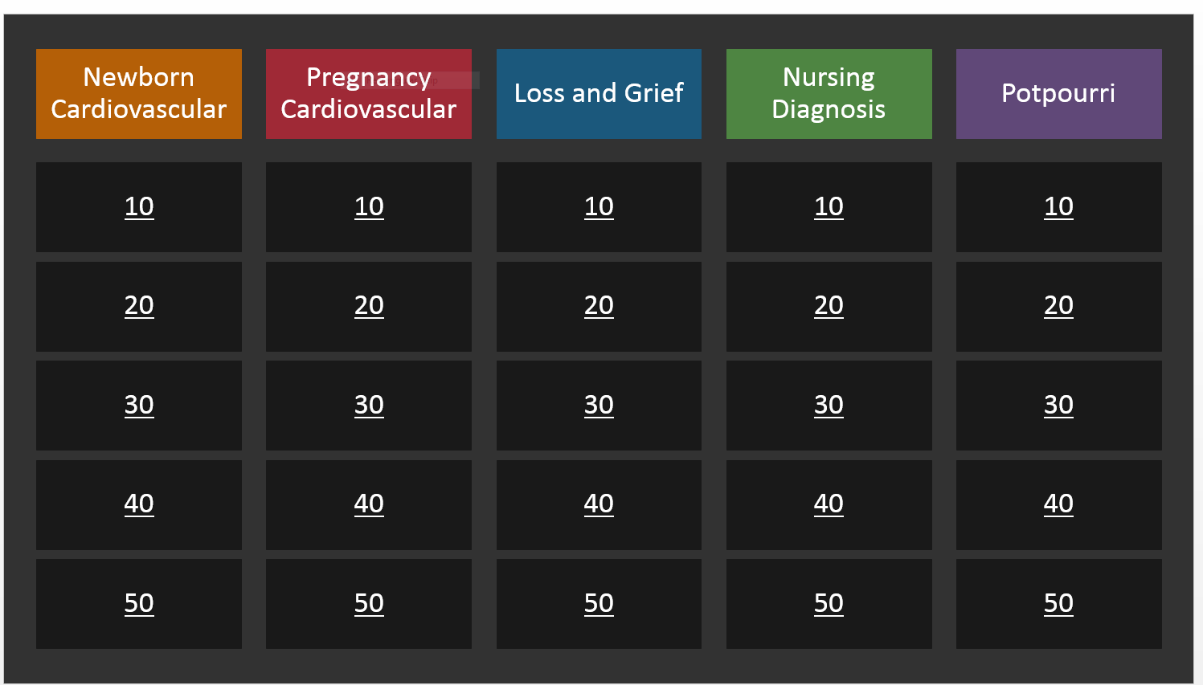
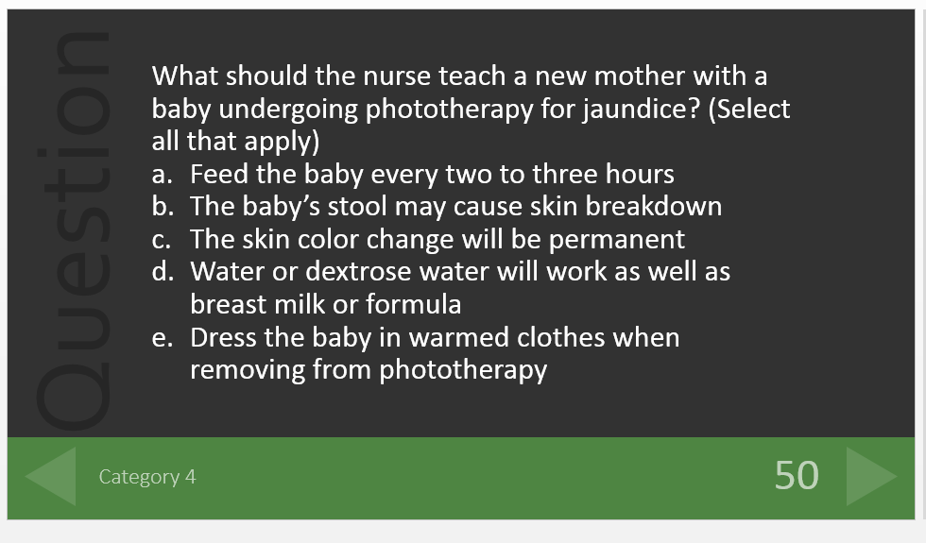
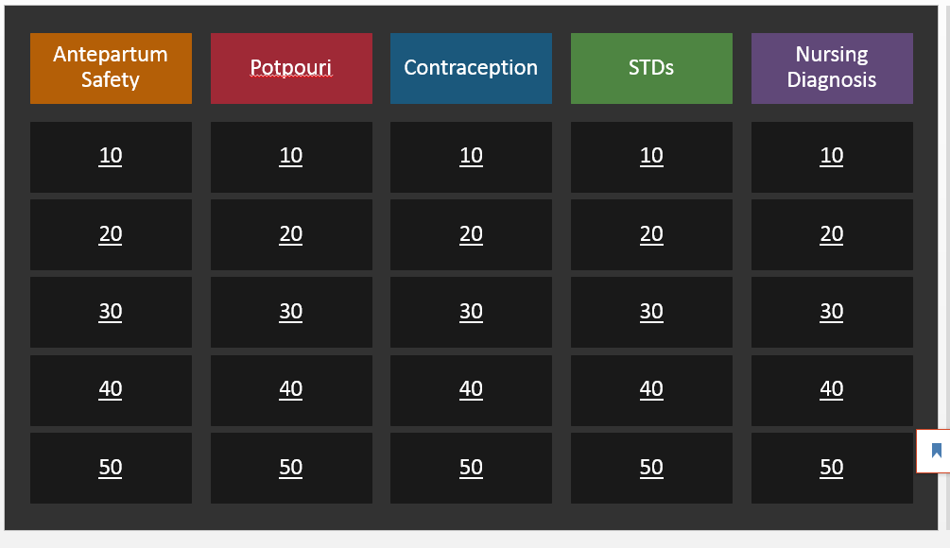
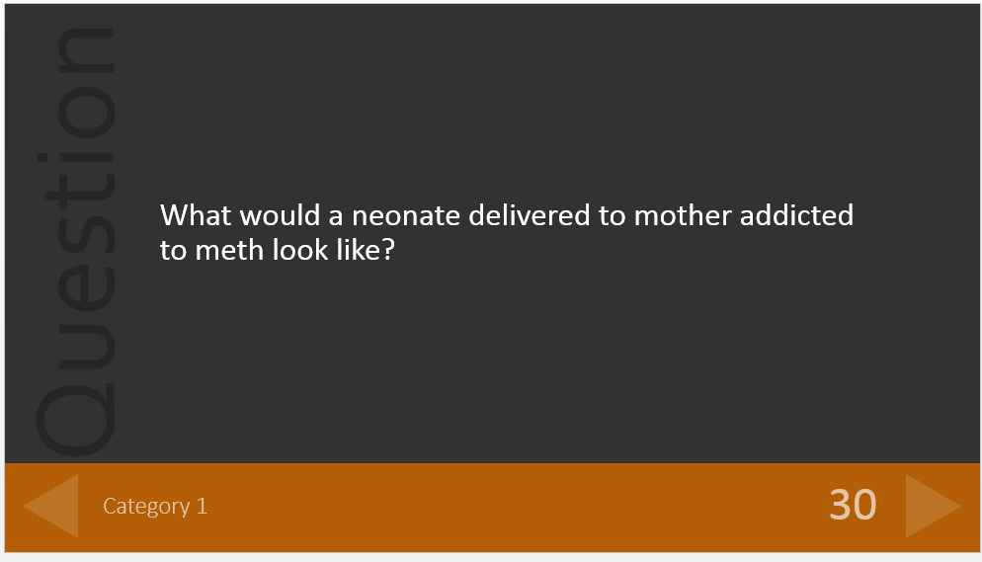

Appendix C
Concept Maps
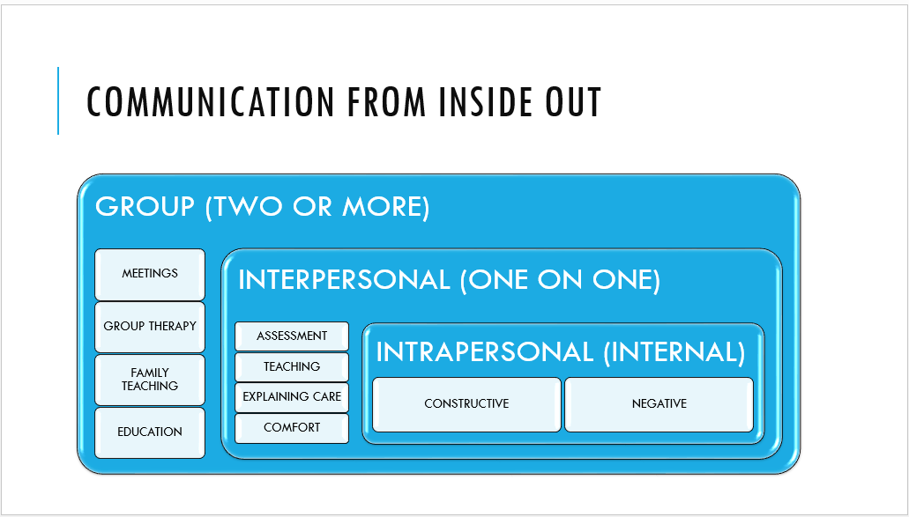
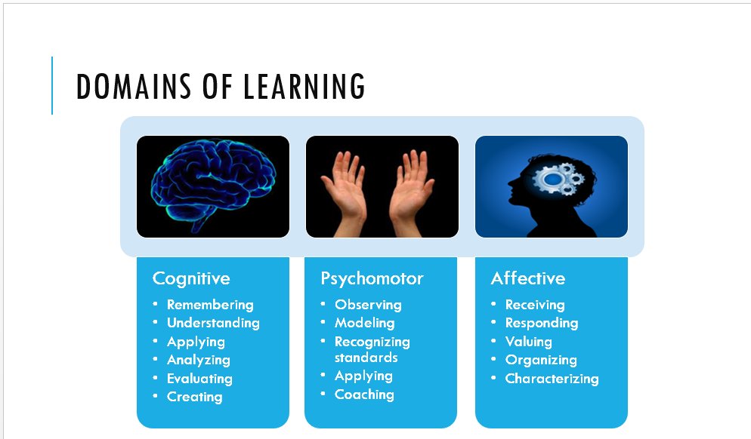
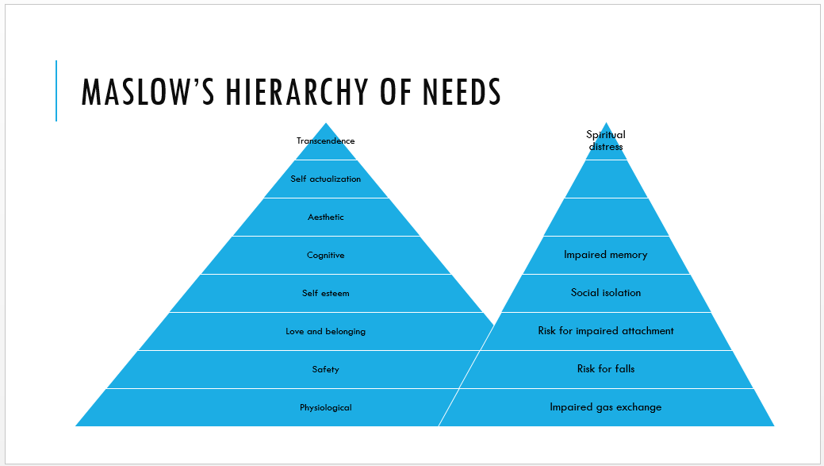

Appendix D
Test Question
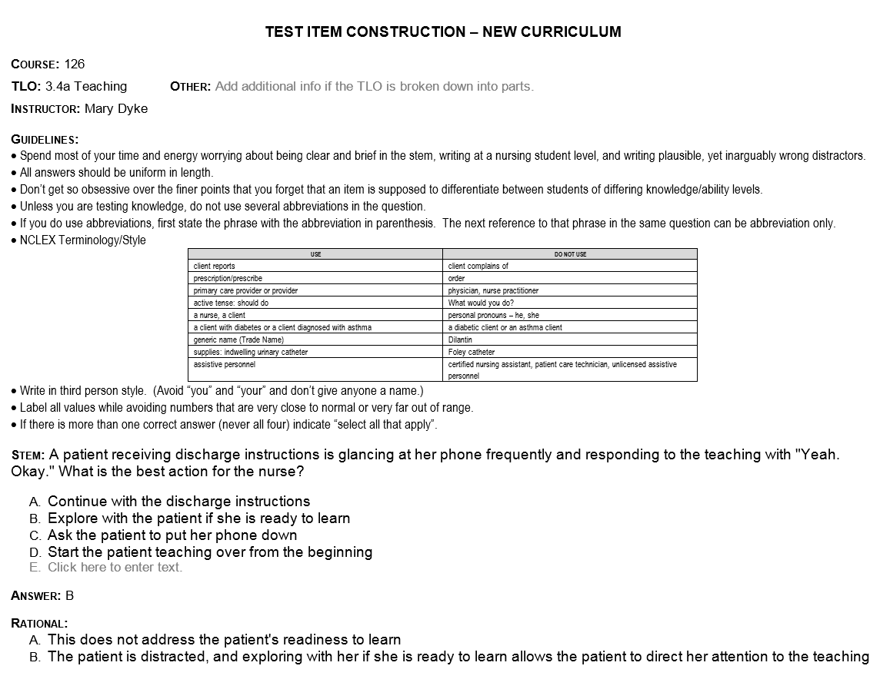
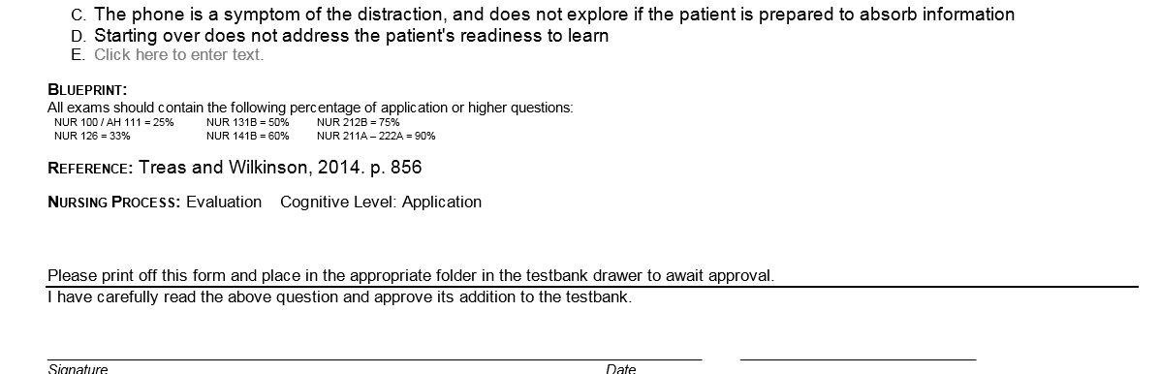

Appendix E
Evaluations
